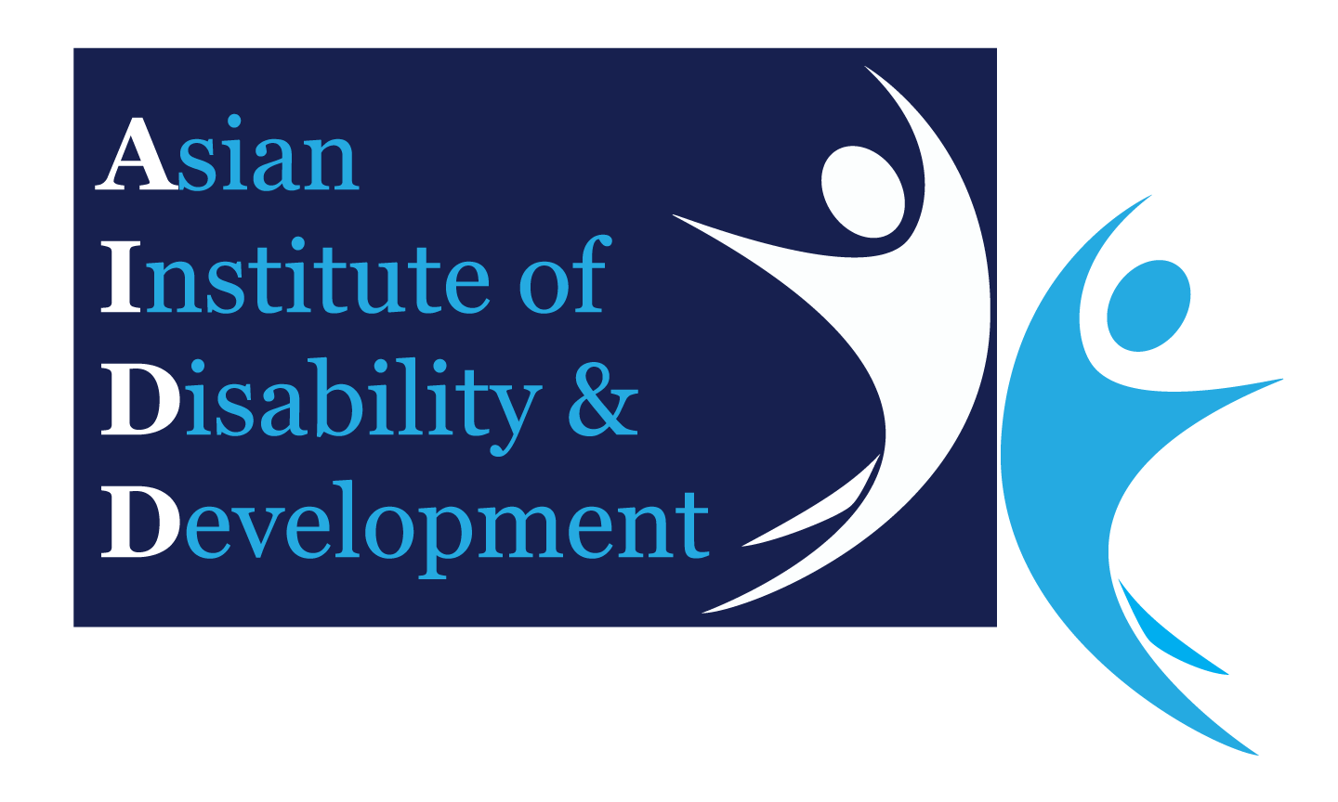Research Approval Application

To Asian Institute of Disability and Development (AIDD) Research Committee

***(Electronic Format Only)***

Submit to: ***disabilityasia@gmail.com***

|  |  |
| --- | --- |
| Date: | 28./02/2020 |

|  |  |  |  |
| --- | --- | --- | --- |
| **Project Title:** | Assessment of direct cost of cerebral palsy management and its effects on family, Bangladesh perspective | | |
| **Names(s), Titles(s), Qualifications, Dept/Locations and Contact Details**  **Asma Akter. MPH students , UniSA, phone: 01711980522 , Id:** 191-  **0044-011** | | | |
| **Principal Investigator:** | | ASMA AKTER | |
| **Associates and Co-Investigator:** | | N/A | |
| **Proposed Date of project commencement:** | | | September 2019 to April 2020 |
| **Proposed Duration of Project:** | | | 8 month |
| **Summary of Project:**  *(Including impact on people with cerebral palsy/other disabilities and academic world)* | | Cerebral Palsy is a long-term chronic medical condition that requires long-term supportive care services. In 1998, the Bangladesh Bureau of Statistics (BBS) estimated that 1.6 per cent of the country’s population suffers from disabilities (1). About 8 million people with disabilities in Bangladesh suffer from a range of disability types and severity. Most of the time it is associated with different impairments or problems like motor problem, visual problem, hearing problem, cognitive problem, feeding difficulties, speech problem, emotional problems, epilepsy, etc. These conditions require diagnosis, treatment and maintenance and all have a significant cost. They often require additional health services, assistive devices, costly transportation, education, home helper etc. In fact, medical costs for children living with cerebral palsy alone were 10 times that of children without CP(6). The overwhelming cost of cerebral palsy treatment leave many parents feeling discouraged and discontinuation of treatment. This increases the complications of complicated CP management become more costly.  According to CDC{6}, Of the $921,000 estimated per person expense of Cerebral Palsy:   * **Indirect costs – 80.6%, or approximately $742,326.** * **Direct medical costs – 10.2%, or $93,942.** * **Direct non-medical costs – 9.2%, or $84,732.**   A study carried out in China in 2003 reported that the average of lifetime economic burden for a CP case was US$67, 0447. Meanwhile, a study of economic burden in Denmark and United State indicated that every CP case in the country requires an average lifetime expenditure of US$1,186,107.11 and US$912,000.0011,16. Comparison in previous studies found that average lifetime cost for direct healthcare costs carried by a family of a child with CP in the United States was US$92,000.00, Denmark US$74,000.00, South Korea US$26,383.00 and China US$2,011.002.  In developed countries government and health insurance bear most of the expense whereas in Bangladesh parents needs to bear the expenses. Government provide a small amount of money as a disable allowance that is not enough for the CP treatment. Moreover there is no health insurance cover the CP problems.  Arranging treatment cost became burden for the family ,and as a consequence other family members suffers and we don’t have enough study about the suffering of the family members, or the effect on the family members due to medical expenses of Cerebral palsy. | |
| **Aims & Significance**  *(Include Research Question/s and Hypothesis)* | | How much a CP cost for treatment. Does the CP management cost has an effect on family?  Hypothesis:   * CP management does not required extra cost? There is no effect of CP management cost on family members, in Bangladesh. ( null hypothesis) * CP Management may have extra cost and There are difference or effects on the family due to CP management cost.(alternative hypothesis)   Objectives:  General:  We want to know the cost of CP management or treatment and how it affects the lifestyle or livelihood to the other family members grossly.  Specific:   * To know the cost (direct) of CP. * How family gets affected because of this cost? * For the benefit of the further research. | |
| **Justification**  *(including literature review and background)* | | * Complications and Cost of Cerebral Palsy (CP) has a negative impact on family which has a negative effect on the management of CP children that ultimately increases the cost again and put more pressure. In our country we have not enough research on the cost of CP or other disability. But we found a lot of research on the cost of CP management in the developed countries. In countries like Bangladesh it might cause more burden on the family and Countries economy. Other related impact that we mentioned here (physical. economical, psychological, social, education, etc.) might have negative impact that was described by the family members or parents of CP children in our regular practice. The finding of this research might inspire for further research and helps the family and the decision makers in their planning or research.   .  . | |
| **Statement of Outcomes & Benefits** | | We will come to know   * How costly the CP management (direct cost) is in Bangladeshi perspective?. * How it affect the life of family members Bangladesh perspective?   We also like to convey the message to the proper authority so that appropriate steps can be taken to reduced or minimized.  And also for the benefit of the further research. | |
| **Method**  Interview method will be This form is divided into 3 parts which are; Part I Parents’ childrens condition, Demographic and income related Information; Part II Children with CP direct cost related information; Part III how the cost of intervention effects on the living of the family members grossly. No details or severity of the affect will be measured. | | | |  |
| **Design** | | Design will be a cross sectional study.  Population size: Due to time limitation and budget constraints sample size will be N=95,  My technique will follow purposive sampling technique,  study area: participants from the whole country who will come to receive treatment at Dr. MR Khan shishu Hospital, Firoza Bari protibondi kalyan , Proyash School.  Study period: 4 months (September 2019- April 2020).  Data will be collected using a researcher designed semi structured questionnaire.  Data will be analyzed with descriptive statistics using Microsoft Excel and SPSS software version 25. | |
| **Participant Inclusion/ Exclusion Criteria** | | Inclusion criteria:   * Parents of CP children. * Who are willing to participate?   Exclusion:   * Parents of CP who are not interested * Parents of others disability. | |

Referrence:

1. ZULFIQAR ALI1, Economic Costs of Disability in Bangladesh, Bangladesh Development Studies Vol. XXXVII, December 2014, No. 4
2. World Bank: Disability and Development Website, Issues Brief on Disability.
3. Metts, R. “Disability and Development.” Background paper prepared for the Disability and Development Research Agenda Meeting, Washington, D.C.: 2004.
4. Measuring Health and Disability, the World Bank. Mont, D. 2007. “.” Lancet, 369:1658-63
5. Sazlina Kamaralzaman1, Teong Chia Ying1, Suziyani Mohamed2, Hasnah Toran2, Noratiqah Satari2 and Nazmin Abdullah2, , Special Volume (1): 156-165 ,THE ECONOMIC BURDEN OF FAMILIES OF CHILDREN WITH CEREBRAL PALSY IN MALAYSIA , Malaysian Journal of Public Health Medicine 2018.
6. Centers for Disease Control and Prevention. Economic costs associated with mental retardation, Cerebral Palsy, hearing loss, and vision impairment — United States, 2003. MMWR 2004; 53:57-9.

### others SOURCES USED :

* [Wiley Online – Lifetime Costs of Cerebral Palsy](http://onlinelibrary.wiley.com/doi/10.1111/j.1469-8749.2008.03190.x/pdf)
* [Cerebral Palsy World](http://www.cerebralpalsyworld.com/cp_economic_impact.aspx)
* [NIH – Medical expenditures attributable to cerebral palsy and intellectual disability among Medicaid-enrolled children](https://www.ncbi.nlm.nih.gov/pubmed/22245730)
* [CDC – (MMWR)](http://www.cdc.gov/mmwr/preview/mmwrhtml/mm5303a4.htm)
* [United Cerebral Palsy](http://ucp.org/wp-content/uploads/2013/02/cp-fact-sheet.pdf)